**Setting up the trial accounts**

**SnowFlake:**

Use the URL below to get to the snowflake trial page:  
<https://signup.snowflake.com/?utm_source=google&utm_medium=paidsearch&utm_campaign=em-za-en-brand-trial-exact&utm_content=go-eta-evg-ss-free-trial&utm_term=c-g-snowflake%20trial-e&_bt=593693896710&_bk=snowflake%20trial&_bm=e&_bn=g&_bg=134435604374&gclsrc=aw.ds&gad_source=1&gclid=CjwKCAiA04arBhAkEiwAuNOsIidffbJxPOR41qi_quMfN1efWex0X1pReRgodgsKa-bqDpZD5YCgAxoCsHQQAvD_BwE>

Fill in your details and click continue:

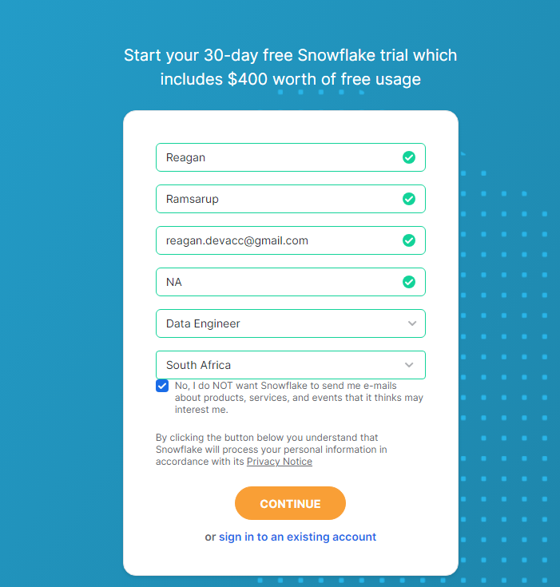

Make sure you sign up for an enterprise trial and choose AWS. There is no local AWS region available so just choose London. Then check the terms box and click get started.

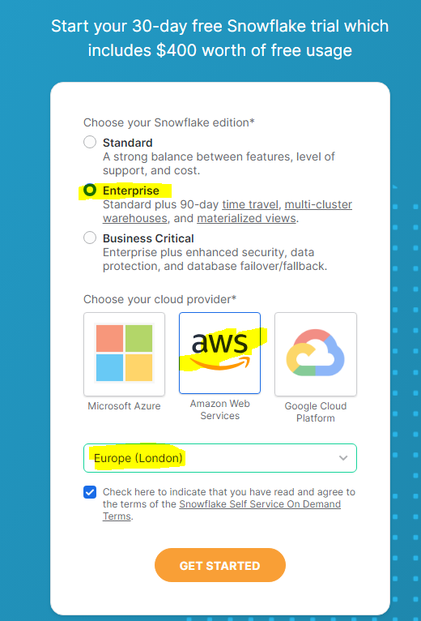

There are some questions afterwards regarding what it will be used for, just choose personal and other, doesn’t really matter.

You will then get a mail to activate your snowflake account a few minutes later. Activate it.

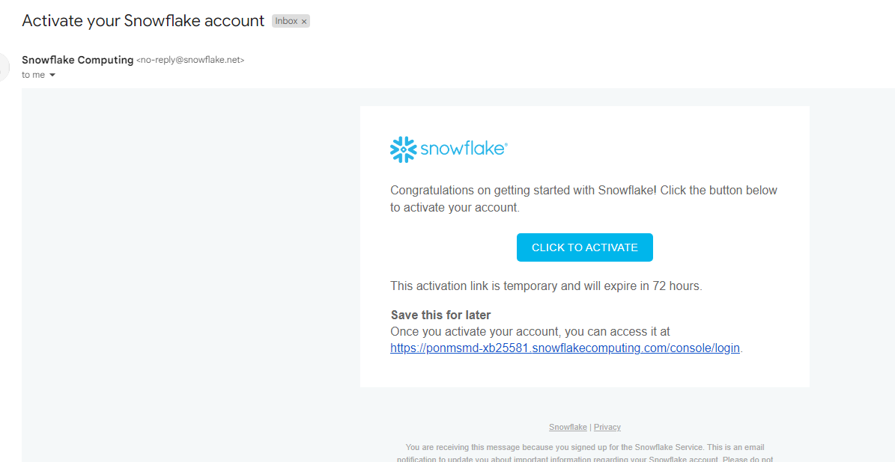

Once you click the link, it will ask you to create a username and password, fill these in and click get started:  
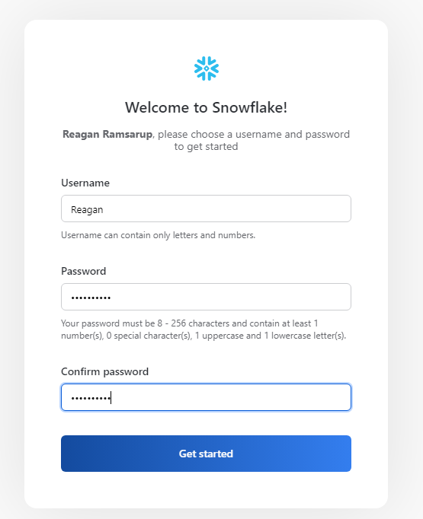

You will then get a welcome email, keep these details as the account number will be very important for the course. You can also use this mail to quickly sign into snowflake:

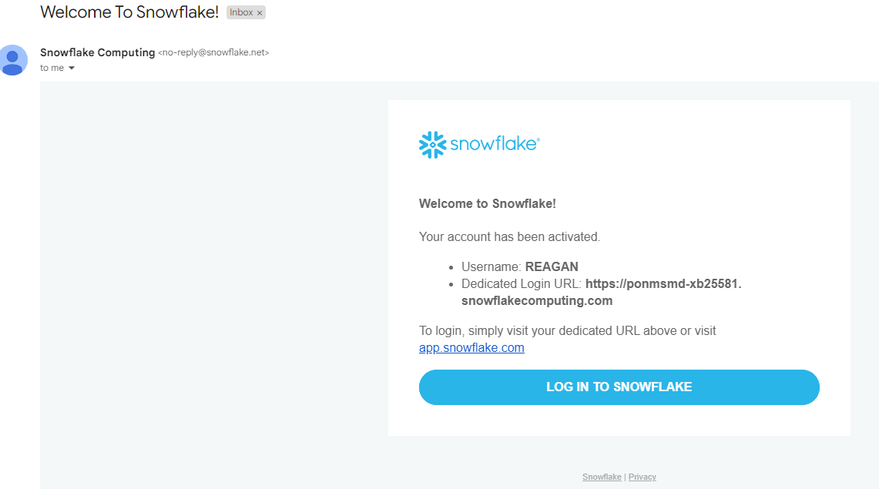

**GITHUB:**

You can use the URL below to signup for a GITHUB Account.

<https://github.com/join>

When you click that link, it will bring you to this page. Fill in your details and click verify to solve a puzzle:

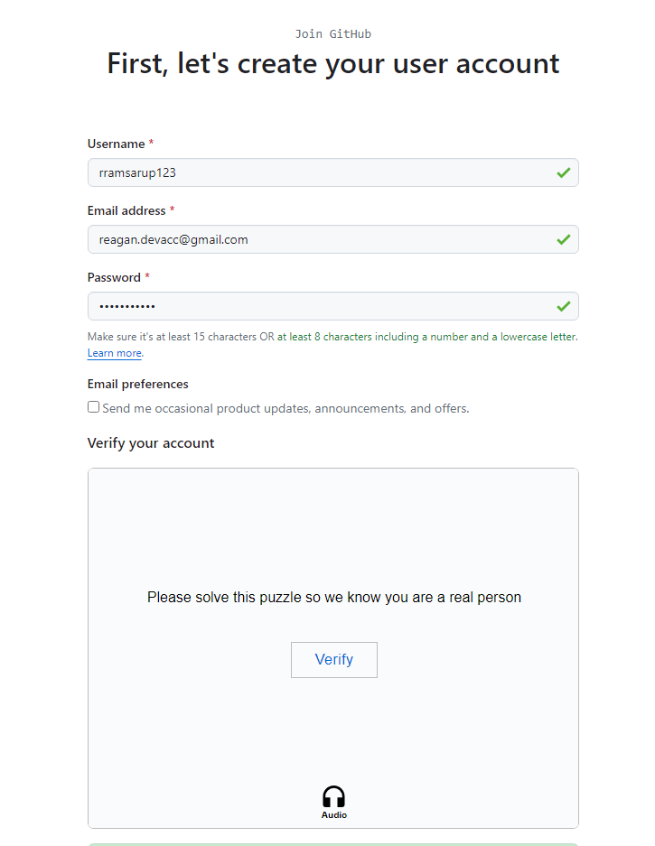

Point the object to the same direction as the hand.

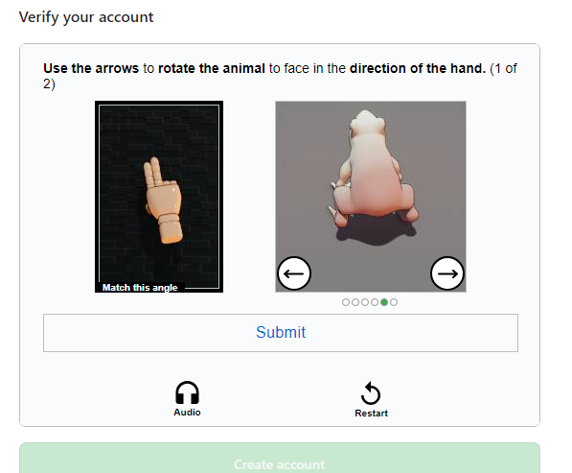

Once you have passed, click create account

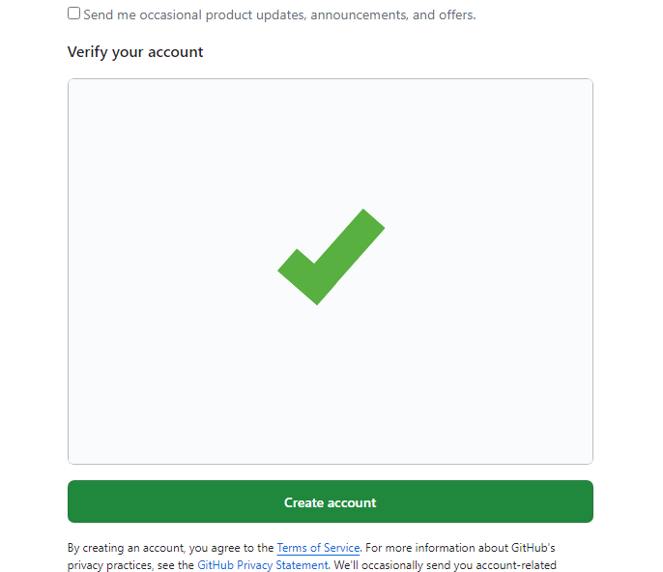

Then you will see a page like so.

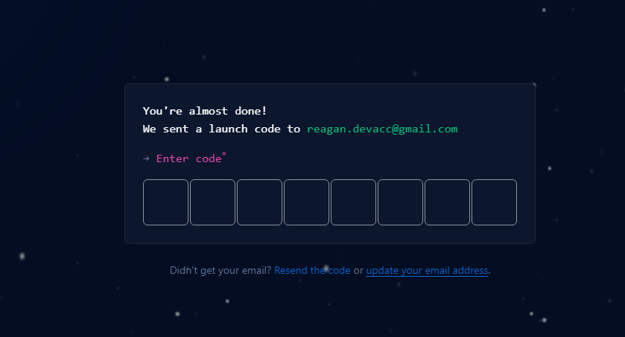

Get the code from your email and populate it in. You will then be in the dashboard.

